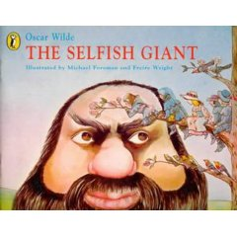

- Where does the story happen? Underline the correct answer. 1/___

in the town in the empire of the dwarfs in the Paradise
in the Giant’s garden in the village
- List the characters. 3/___

- Where did the children play after school? 1/___

4. What proves that the Giant was selfish? 1/___

5. What did the Giant’s garden look like in spring? Complete the sentences. 3/___

In the garden of the Selfish Giant it was still . The did not care to sing, and the trees forgot to .

6. Who stayed in the garden? Match. 4/___

The Snow he was dressed in grey, his breath was like ice
The Hail he roared all day
The Frost she covered up the grass with her white cloak
The North Wind he rattled on the roof

7. Underline the answers in the text. 5/___

- What kind of music did the Giant hear one morning?
- What did he see in his garden?
- Why were the trees glad?
- What did the trees and flowers do?
- Where was it still winter in the garden?

8. What did the Giant decide? Copy it. 1/___

9. Put the following sentences in order. 6/___

- The little boy didn’t run away, because his eyes were so full of tears that he did not see the Giant.
- The children were so frightened that they all run away, and the garden became winter again.
- The Giant crept downstairs in the garden.
- The little boy flung his arms around the Giant’s neck, and kissed him.
- The Giant stole up behind the boy and put him up into the tree.
- The children saw that the Giant was not wicked any longer.

10. Why did the Giant loved that boy? 1/___

11. What was the old Giant like? 2/___

12. True or false? 5/___

- In the furthest corner of the garden was a tree covered with yellow blossoms.
- The little boy he loved stood underneath the tree.
- The child’s hands were only hurt.
- He was wounded by a thorn.
- The wounds were the wounds of Love.

13. What does the following sentence mean? Explain it. 2/___

„…today you shall come with me to my garden, which is Paradise.”

Total marks: 35/___

